**CPS 592**

**VISUAL COMPUTING AND MIXED REALITY**

**ASSIGNMENT 3**

**PROJECT REPORT**

**GROUP MEMBERS:**

NAVEENA KATPALLY

101551664

SHRUTHI KURA

101516439

**Problem1:**

In this assignment, you will implement an Augmented Reality (AR) application.

First, you must design an AR-oriented application. Then, you use ARToolkit, Vuforia, or any different AR frameworks (Wikitude, DroidAR) to implement your designed application.

Summarize what you have done to the application, for example:

* How to create your own AR markers (if any).
* How to render the virtual objects.
* How to interact with the virtual objects (if any).
* Is it reasonable to use AR for your designed application?
* Your own comments/remarks.

**Steps to create AR marker:**

* First we need to sign into vuforia development portal with our registered mail id.Select Develop tab and choose License Manager.Then add a License Key.
* Now select Target Manager and create database.
* Later add target and select the image which you want as a marker and upload it.Wait until the status of Target changes to active once it is done click on download database by selecting the Unity Editor which downloads a .unity package.
* Open the downloaded .unity package which automatically opens in unity and import the package.

Here we have created our own markers as shown below:

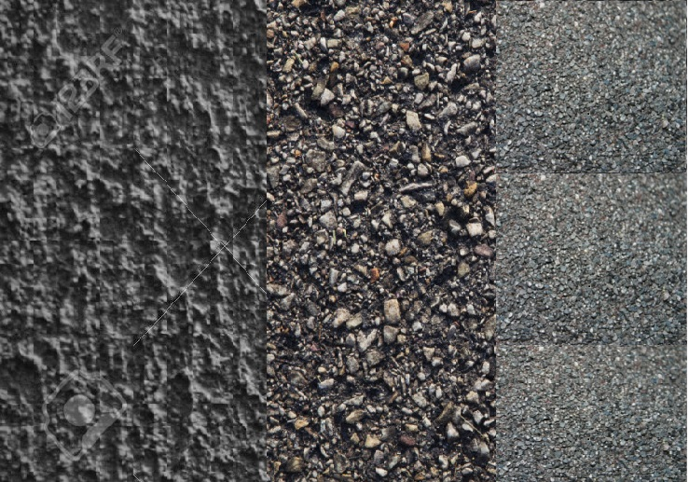

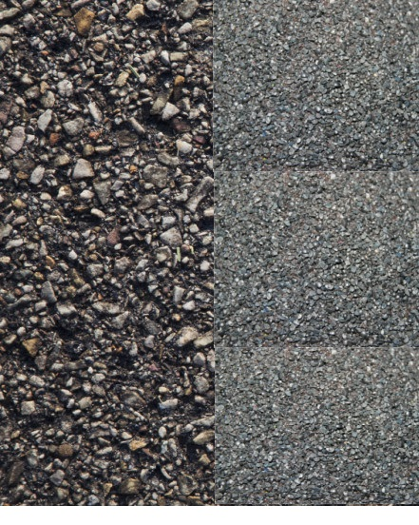 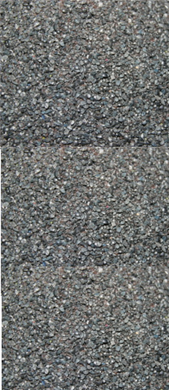

**Steps to import our own database:**

* Go to Assets🡪 AR camera🡪 Inspector tab 🡪Data set Load behaviour🡪select the name of the .unity package which we have imported earlier and make active.
* Go to Assets🡪 vuforia🡪 prefabs 🡪 drag image target on the scene 🡪Image target behaviour🡪change the dataset from empty to our database and the image target will be changed automatically to our own marker.

**Steps to render and interact with the virtual objects:**

* Go to Assets store 🡪download the 3D model which we want🡪Import the 3D model🡪go to the 3D model object in assets🡪 drag the object under the image target ie., on the marker🡪change the object position, rotation and scaling as per our requirements.
* In our application we took few objects like goblin robber,Treasurechest(i.e., castle).Then we had set the animations for the goblin robber such as attack,death,idle,defend etc., by changing the generic to legacy in rig tab.Also we need to change the wrap mode to loop from default for few animations like walk,run,attack etc.

**Issues and solutions:**

* Faced an issue during the creation of markers. We did not choose an appropriate marker because of that objects did not appear on marker. Later on we had chosen the proper marker with good features and solved the above issue.
* Also faced issues while setting the object positions, rotation and scaling. After spending much time on rendering those objects we got to know how to set their positions, rotation and scaling.

**Output:**

**On marker1:**

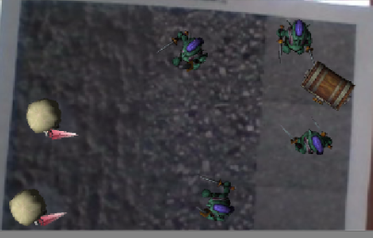

**On marker2:**

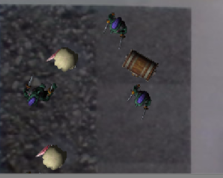

**On marker3:**

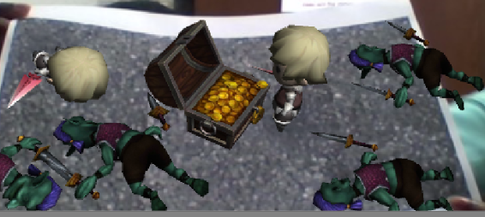

**Contribution of group members:**

Naveena Katpally : Created the marker.

Shruthi Kura : Rendered and interacted with virtual objects.

Combined effort: Developed the application and discussed issues and solutions.